Case Study

on

**INFORMATICA**

**Case study by,**

Mouli S,

Batch – 02,

moulisankar2002@outlook.com.

**Contents**

1. Understandings of Case Study ……………………………………………3
2. Database ……………………………………………………………………………...4-7
   1. Creation ……………………………………………………………..4
   2. Insertion …………………………………………………………….5-7
3. Case Study Questions ………………………………………………………….8-14
   1. Question 1 …………………………………………………………8
   2. Question 2 …………………………………………………………9
   3. Question 3 …………………………………………………………10
   4. Question 4 …………………………………………………………11
   5. Question 5 …………………………………………………………12
   6. Question 6 …………………………………………………………13

**1. Understandings of Case Study**

Btech-Chai-Wala is a start-up company by Vinit and his friends. Now-a-days in the advancement of the Internet and technologies and by considering the peoples locations they decided to start online streaming services instead of the Television. So, they have created the new streaming service which will allows only the beverage related contents.

They started subscriptions like weekly, monthly and Annual. Vinit has played roles in IT sectors like Data Analyst, Enterprise Data Architect, Principal Architect etc.

This case study questions and analysis will help the start-up to investment decisions and new features to improve Btech-Chai-Wala business by using informatica an ETL tool.

**2.1 & 2.2 Queries:**

-- Creating the database

CREATE DATABASE [btech-chai-wala];

-- Using the btech-chai-wala database

USE [btech-chai-wala];

-- Creating tables plans, subsricptions and customer

-- Creating plans table

CREATE TABLE [dbo].[plans]

(

plan_id INT NOT NULL PRIMARY KEY IDENTITY(1,1),

plan_name VARCHAR(100),

plan_price DECIMAL

);

-- Creating subscriptions table

CREATE TABLE [dbo].[subscriptions]

(

subscrip_id INT NOT NULL PRIMARY KEY IDENTITY(1,1),

cust_id INT,

plan_id INT,

start_date DATE,

is_active VARCHAR(1)

);

-- Creating customer table

CREATE TABLE [dbo].[customer]

(

cust_id INT NOT NULL PRIMARY KEY IDENTITY(1,1),

cust_name VARCHAR(100),

cust_city VARCHAR(100),

cust_dob DATE

);

-- Inserting the values into the plans, subscriptions and customer tables

--plans values

SET IDENTITY_INSERT [dbo].[plans] ON;

INSERT INTO [dbo].[plans](plan_id,plan_name,plan_price) VALUES(1,'Trail',0.00);

INSERT INTO [dbo].[plans](plan_id,plan_name,plan_price) VALUES(2,'Basic_Monthly',499.00);

INSERT INTO [dbo].[plans](plan_id,plan_name,plan_price) VALUES(3,'Pro_Monthly',999.00);

INSERT INTO [dbo].[plans](plan_id,plan_name,plan_price) VALUES(4,'Pro_Annual',11998.00);

INSERT INTO [dbo].[plans](plan_id,plan_name,plan_price) VALUES(5,'Chrun',NULL);

SET IDENTITY_INSERT [dbo].[plans] OFF;

-- subscriptions values

SET IDENTITY_INSERT [dbo].[subscriptions] ON;

INSERT INTO [dbo].[subscriptions](subscrip_id, cust_id, plan_id, start_date, is_active) VALUES(1,1,2,'2019-08-01',0);

INSERT INTO [dbo].[subscriptions](subscrip_id, cust_id, plan_id, start_date, is_active) VALUES(2,1,3,'2019-08-08',0);

INSERT INTO [dbo].[subscriptions](subscrip_id, cust_id, plan_id, start_date, is_active) VALUES(3,5,1,'2020-01-17',0);

INSERT INTO [dbo].[subscriptions](subscrip_id, cust_id, plan_id, start_date, is_active) VALUES(4,5,1,'2020-03-17',0);

INSERT INTO [dbo].[subscriptions](subscrip_id, cust_id, plan_id, start_date, is_active) VALUES(5,5,3,'2021-03-24',0);

INSERT INTO [dbo].[subscriptions](subscrip_id, cust_id, plan_id, start_date, is_active) VALUES(6,5,3,'2021-03-24',0);

INSERT INTO [dbo].[subscriptions](subscrip_id, cust_id, plan_id, start_date, is_active) VALUES(7,5,5,'2021-04-29',0);

INSERT INTO [dbo].[subscriptions](subscrip_id, cust_id, plan_id, start_date, is_active) VALUES(8,5,5,'2022-04-30',1);

INSERT INTO [dbo].[subscriptions](subscrip_id, cust_id, plan_id, start_date, is_active) VALUES(9,6,1,'2020-05-31',0);

INSERT INTO [dbo].[subscriptions](subscrip_id, cust_id, plan_id, start_date, is_active) VALUES(10,6,2,'2020-06-07',0);

INSERT INTO [dbo].[subscriptions](subscrip_id, cust_id, plan_id, start_date, is_active) VALUES(11,9,1,'2020-06-22',0);

INSERT INTO [dbo].[subscriptions](subscrip_id, cust_id, plan_id, start_date, is_active) VALUES(12,9,3,'2020-06-29',0);

INSERT INTO [dbo].[subscriptions](subscrip_id, cust_id, plan_id, start_date, is_active) VALUES(13,8,1,'2020-07-06',0);

INSERT INTO [dbo].[subscriptions](subscrip_id, cust_id, plan_id, start_date, is_active) VALUES(14,8,3,'2020-07-13',0);

INSERT INTO [dbo].[subscriptions](subscrip_id, cust_id, plan_id, start_date, is_active) VALUES(15,7,1,'2020-08-01',0);

INSERT INTO [dbo].[subscriptions](subscrip_id, cust_id, plan_id, start_date, is_active) VALUES(16,1,1,'2020-08-07',1);

INSERT INTO [dbo].[subscriptions](subscrip_id, cust_id, plan_id, start_date, is_active) VALUES(17,7,2,'2020-08-08',0);

INSERT INTO [dbo].[subscriptions](subscrip_id, cust_id, plan_id, start_date, is_active) VALUES(18,9,4,'2020-08-29',0);

INSERT INTO [dbo].[subscriptions](subscrip_id, cust_id, plan_id, start_date, is_active) VALUES(19,2,1,'2020-09-20',0);

INSERT INTO [dbo].[subscriptions](subscrip_id, cust_id, plan_id, start_date, is_active) VALUES(20,2,1,'2020-09-20',0);

INSERT INTO [dbo].[subscriptions](subscrip_id, cust_id, plan_id, start_date, is_active) VALUES(21,2,4,'2020-09-27',0);

INSERT INTO [dbo].[subscriptions](subscrip_id, cust_id, plan_id, start_date, is_active) VALUES(22,2,4,'2020-09-27',0);

INSERT INTO [dbo].[subscriptions](subscrip_id, cust_id, plan_id, start_date, is_active) VALUES(23,6,4,'2020-10-21',0);

INSERT INTO [dbo].[subscriptions](subscrip_id, cust_id, plan_id, start_date, is_active) VALUES(24,2,1,'2020-11-19',0);

INSERT INTO [dbo].[subscriptions](subscrip_id, cust_id, plan_id, start_date, is_active) VALUES(25,10,1,'2020-11-19',0);

INSERT INTO [dbo].[subscriptions](subscrip_id, cust_id, plan_id, start_date, is_active) VALUES(26,2,5,'2020-11-26',1);

INSERT INTO [dbo].[subscriptions](subscrip_id, cust_id, plan_id, start_date, is_active) VALUES(27,10,5,'2021-11-26',1);

INSERT INTO [dbo].[subscriptions](subscrip_id, cust_id, plan_id, start_date, is_active) VALUES(28,3,1,'2020-12-15',0);

INSERT INTO [dbo].[subscriptions](subscrip_id, cust_id, plan_id, start_date, is_active) VALUES(29,3,1,'2020-12-15',0);

INSERT INTO [dbo].[subscriptions](subscrip_id, cust_id, plan_id, start_date, is_active) VALUES(30,3,2,'2020-12-22',0);

INSERT INTO [dbo].[subscriptions](subscrip_id, cust_id, plan_id, start_date, is_active) VALUES(31,4,2,'2020-12-22',0);

INSERT INTO [dbo].[subscriptions](subscrip_id, cust_id, plan_id, start_date, is_active) VALUES(32,4,3,'2021-03-29',1);

INSERT INTO [dbo].[subscriptions](subscrip_id, cust_id, plan_id, start_date, is_active) VALUES(33,3,3,'2021-03-29',1);

INSERT INTO [dbo].[subscriptions](subscrip_id, cust_id, plan_id, start_date, is_active) VALUES(34,6,1,'2021-05-31',0);

INSERT INTO [dbo].[subscriptions](subscrip_id, cust_id, plan_id, start_date, is_active) VALUES(35,6,2,'2021-06-07',0);

INSERT INTO [dbo].[subscriptions](subscrip_id, cust_id, plan_id, start_date, is_active) VALUES(36,9,1,'2021-06-22',0);

INSERT INTO [dbo].[subscriptions](subscrip_id, cust_id, plan_id, start_date, is_active) VALUES(37,9,3,'2021-06-29',0);

INSERT INTO [dbo].[subscriptions](subscrip_id, cust_id, plan_id, start_date, is_active) VALUES(38,8,1,'2021-07-06',0);

INSERT INTO [dbo].[subscriptions](subscrip_id, cust_id, plan_id, start_date, is_active) VALUES(39,8,3,'2021-07-13',1);

INSERT INTO [dbo].[subscriptions](subscrip_id, cust_id, plan_id, start_date, is_active) VALUES(40,7,1,'2021-08-01',1);

INSERT INTO [dbo].[subscriptions](subscrip_id, cust_id, plan_id, start_date, is_active) VALUES(41,9,4,'2022-08-29',1);

INSERT INTO [dbo].[subscriptions](subscrip_id, cust_id, plan_id, start_date, is_active) VALUES(42,6,4,'2021-10-21',1);

SET IDENTITY_INSERT [dbo].[subscriptions] OFF;

-- customer values

SET IDENTITY_INSERT [dbo].[customer] ON;

INSERT INTO [dbo].[customer](cust_id, cust_name, cust_city, cust_dob) VALUES(1,'Chaitanya','Bangalore', 2001-02-02');

INSERT INTO [dbo].[customer](cust_id, cust_name, cust_city, cust_dob) VALUES(2,'Harini','Mumbai', ‘2001-07-19’);

INSERT INTO [dbo].[customer](cust_id, cust_name, cust_city, cust_dob) VALUES(3,'Indu','Chennai', '2001-01-21');

INSERT INTO [dbo].[customer](cust_id, cust_name, cust_city, cust_dob) VALUES(4,'Jameela','Hyderabad', '2002-05-01');

INSERT INTO [dbo].[customer](cust_id, cust_name, cust_city, cust_dob) VALUES(5,'Neeha','Bangalore', '2000-03-15');

INSERT INTO [dbo].[customer](cust_id, cust_name, cust_city, cust_dob) VALUES(6,'Reshma','Mumbai', '2001-02-02');

INSERT INTO [dbo].[customer](cust_id, cust_name, cust_city, cust_dob) VALUES(7,'Sahithi','Chennai', '2000-11-02');

INSERT INTO [dbo].[customer](cust_id, cust_name, cust_city, cust_dob) VALUES(8,'Sharmila','Hyderabad', '2001-04-22');

INSERT INTO [dbo].[customer](cust_id, cust_name, cust_city, cust_dob) VALUES(9,'Sreelakshmi','Bangalore', '2000-06-17');

INSERT INTO [dbo].[customer](cust_id, cust_name, cust_city, cust_dob) VALUES(10,'Subasri','Mumbai', '2002-01-30');

SET IDENTITY_INSERT [dbo].[customer] OFF;

-- Verifying the values inserted properly

SELECT * FROM [dbo].[plans];

SELECT * FROM [dbo].[subscriptions];

SELECT * FROM [dbo].[customer];

**Screenshots:**

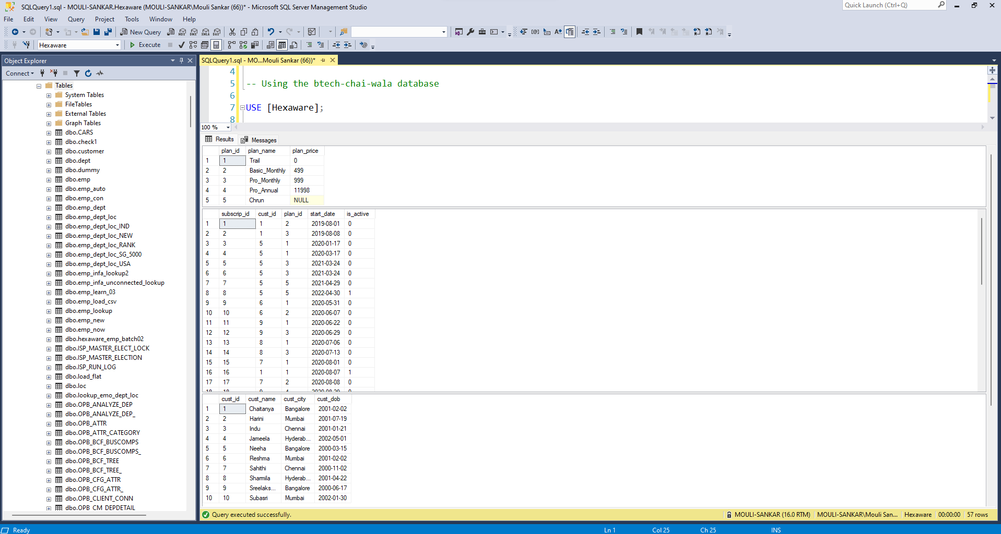

**3. Case Study Questions**

**3.1 Question 1**

**Design Job in Informatica to find how many customers of BTech-Chai-Wala have activate subscription as on 5th May 20 21?**

Mappings:

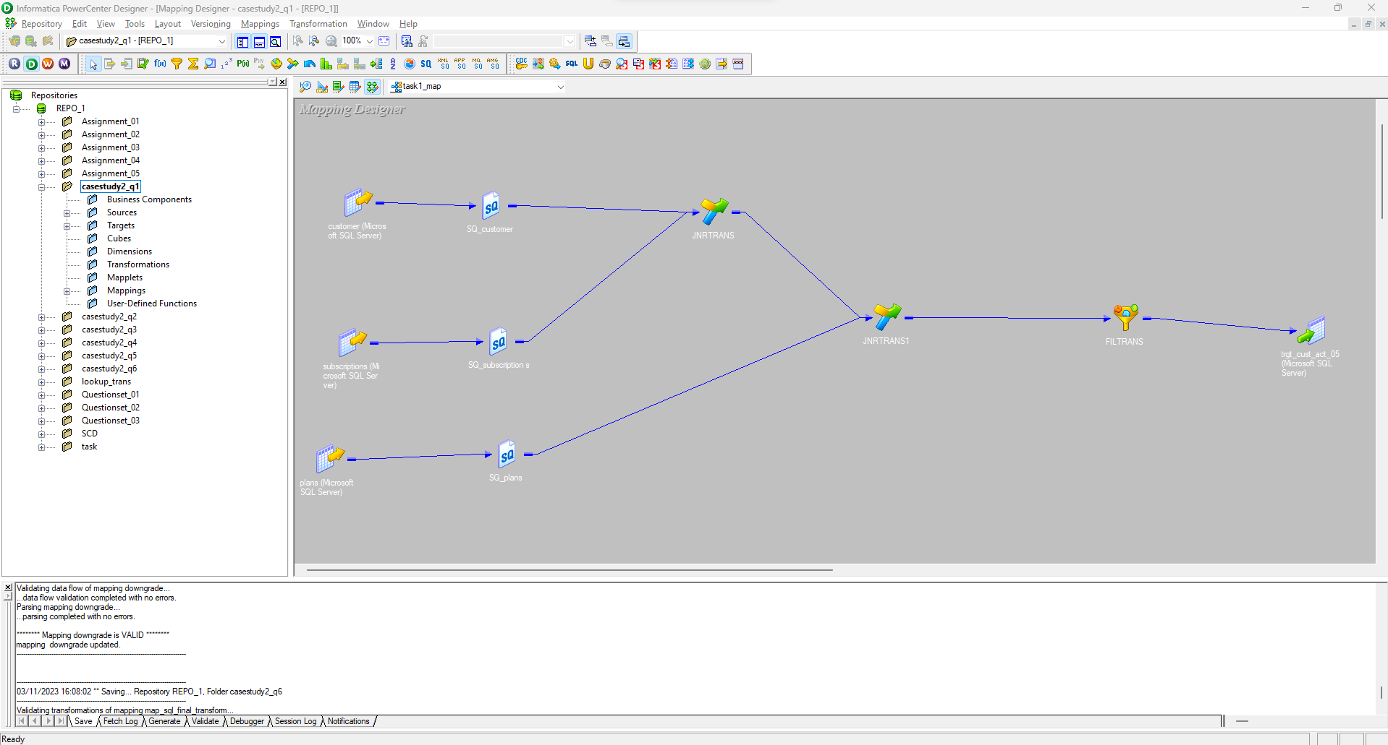

Workflows with run properties:

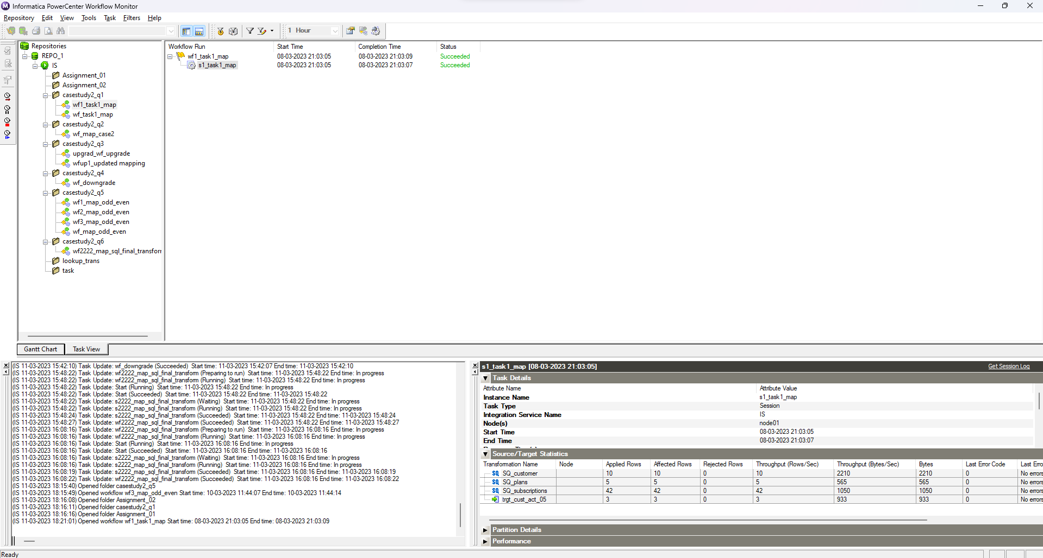

Database output:

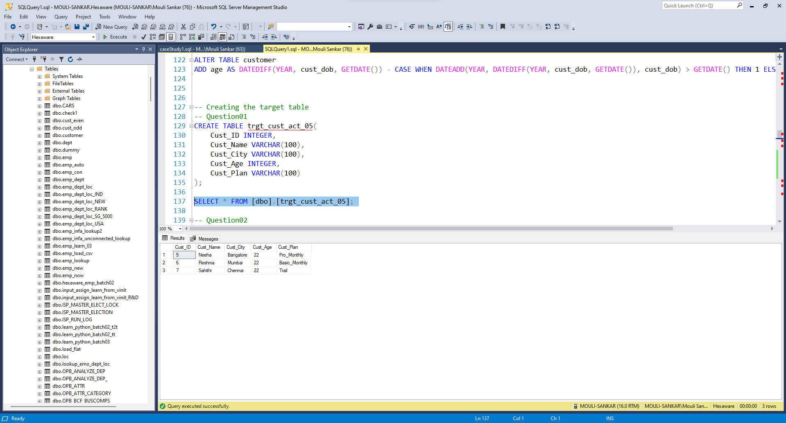**3.2 Question 2**

**Design Job in Informatica so that sum of customer’s payment for all 4 the plan_name values at 2020-12-31 can be summarized?**

Mappings:

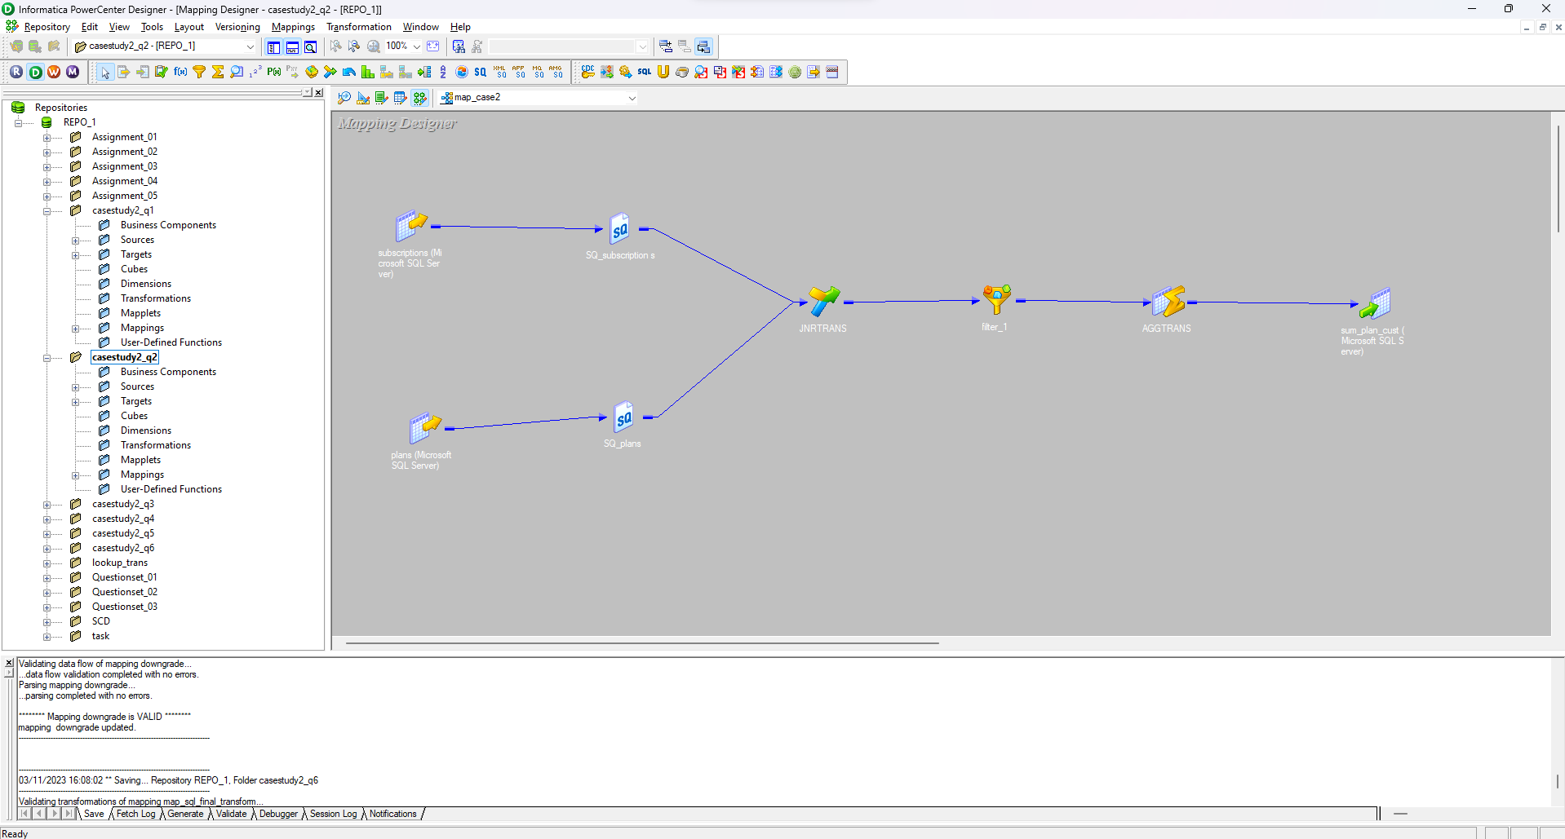

Workflow with run properties:

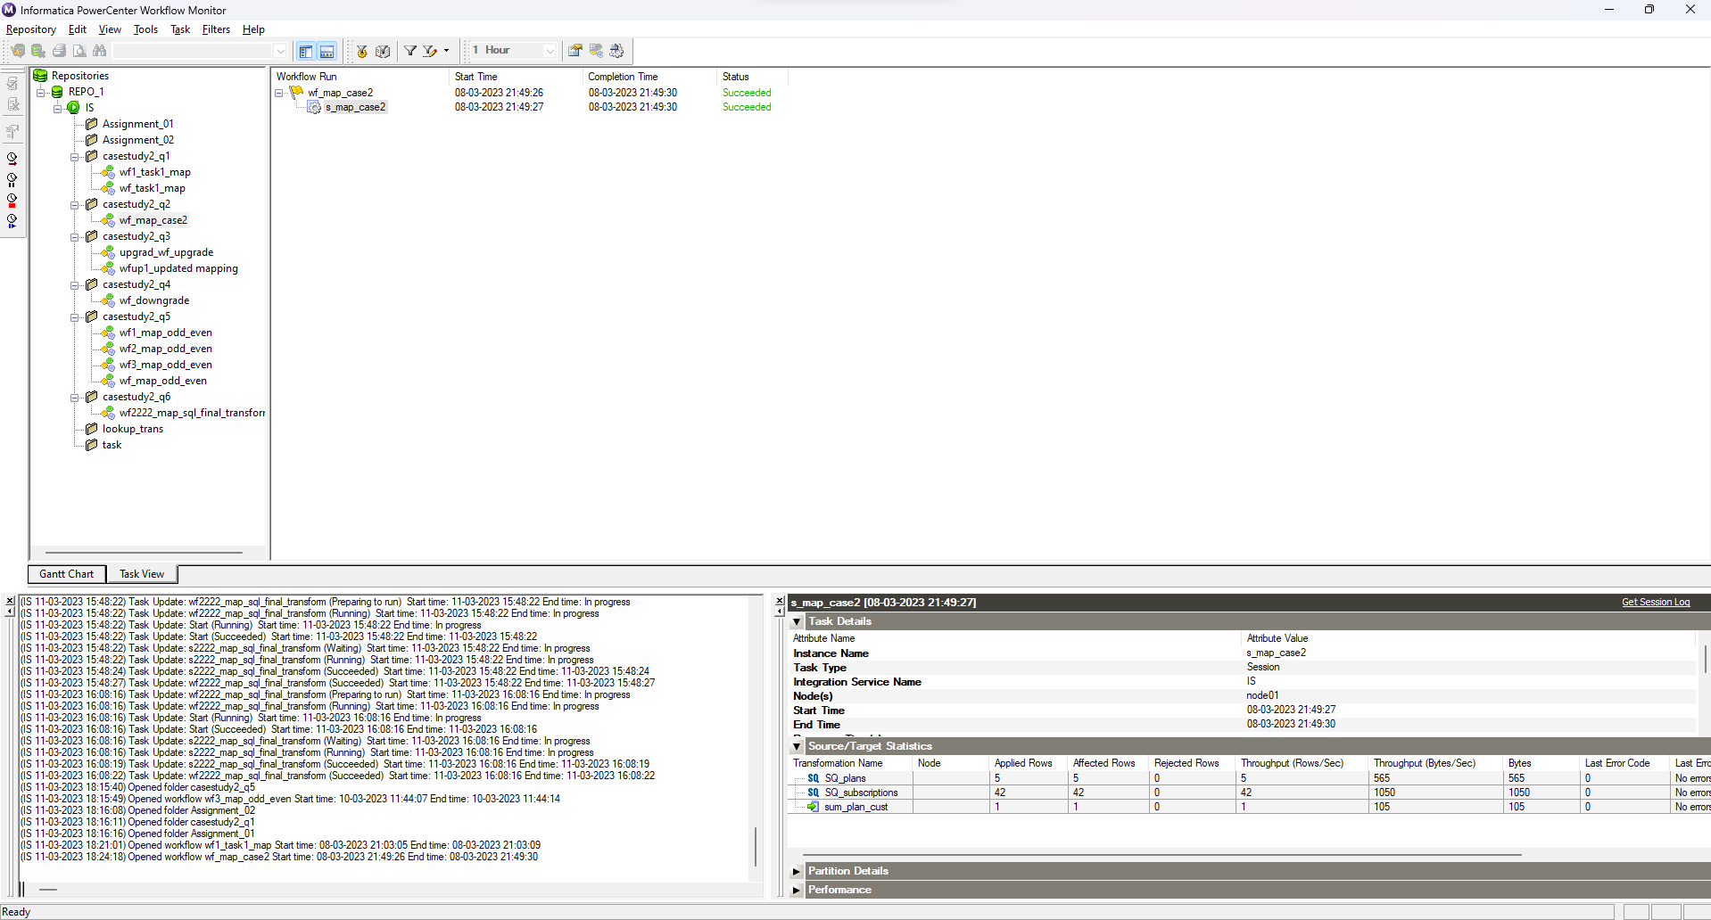

Database output:

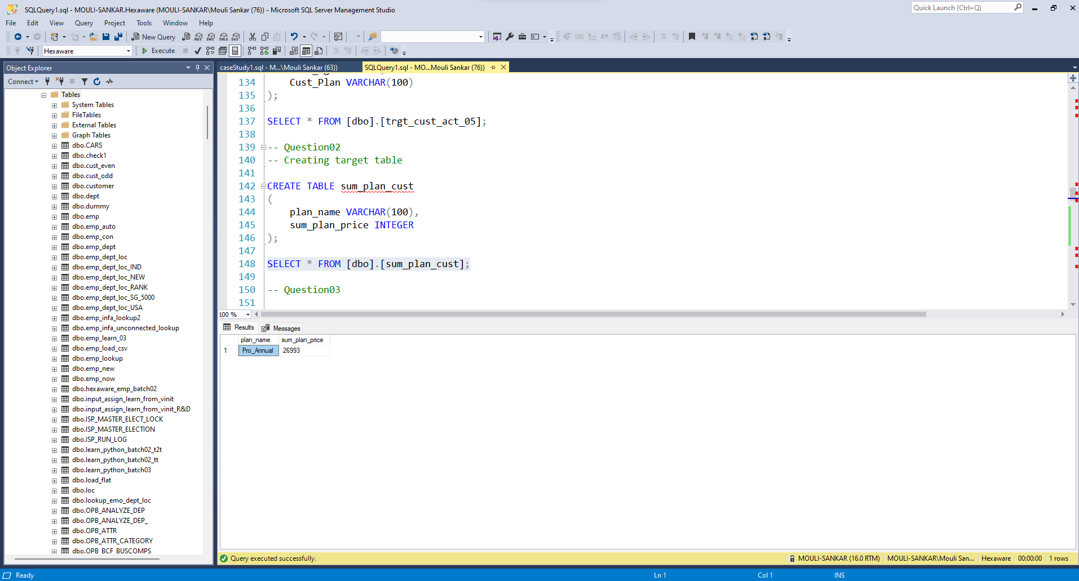**3.3 Question 3**

**Design Job in Informatica to find how many customers upgraded annual plan between 2020 and 2021?**

Mappings:

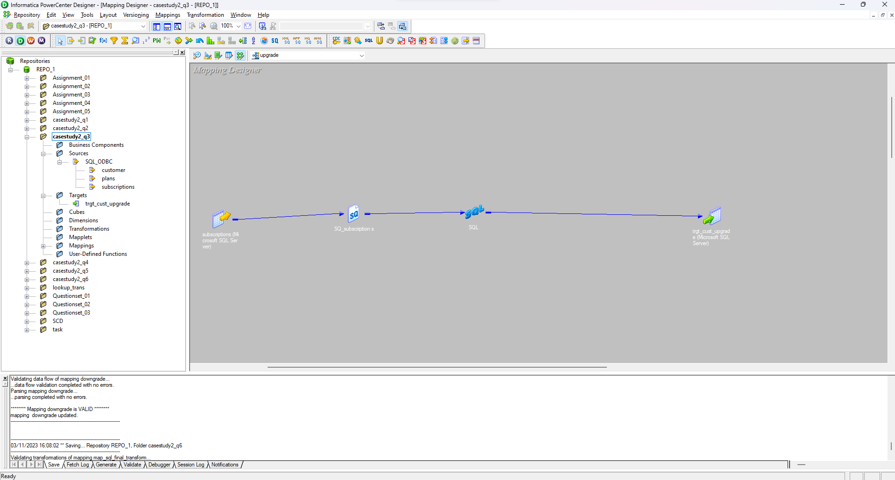

Workflow with run properties:

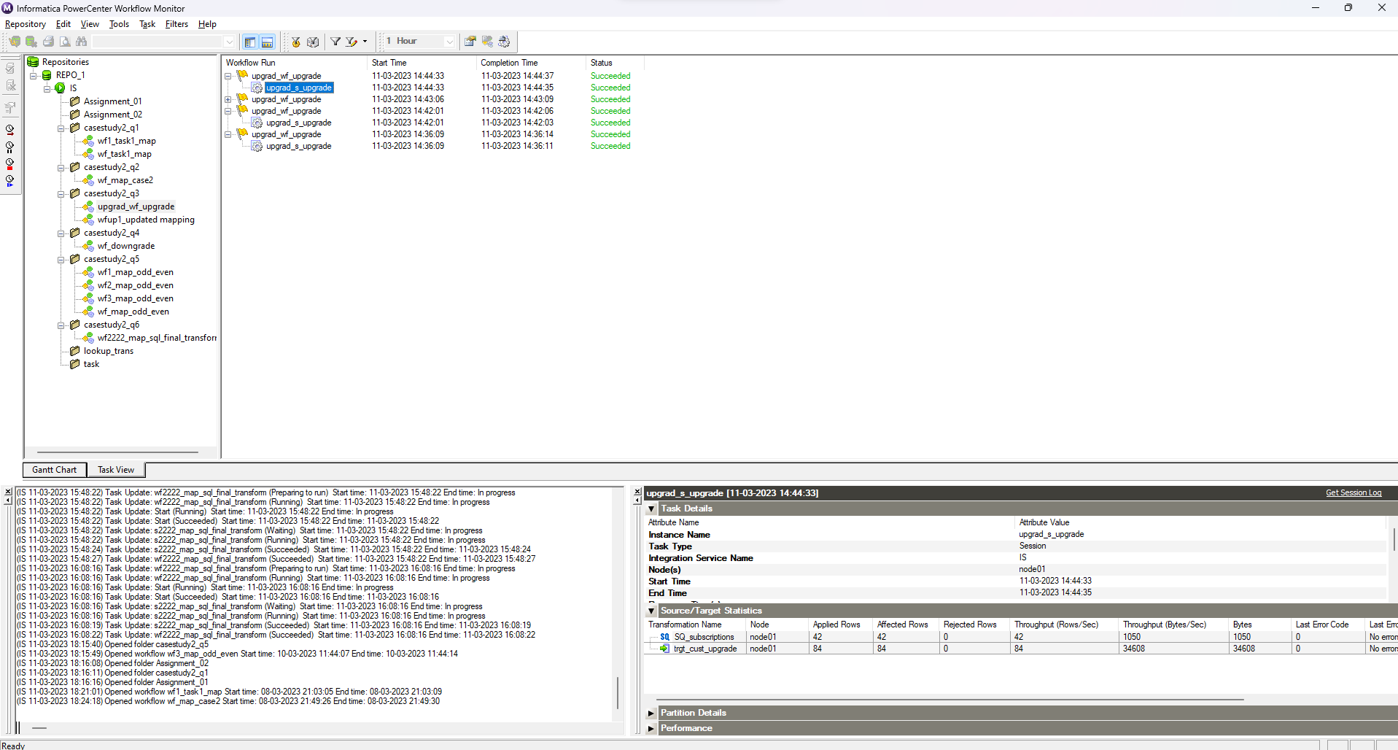

Database output:

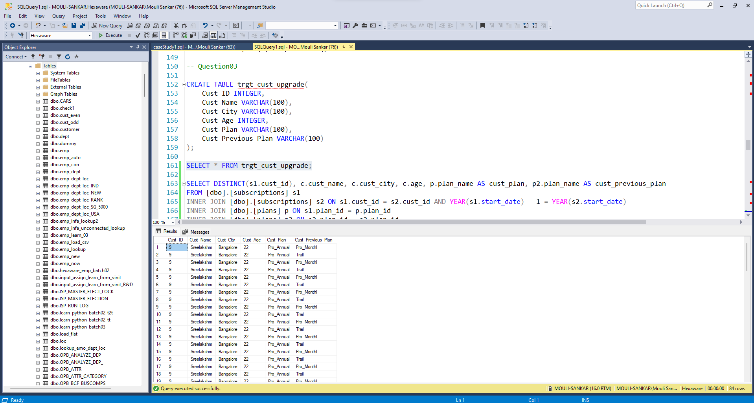**3.4 Question 4**

**Design Job in Informatica to find how many customers downgraded from a pro monthly to a basic monthly plan in 2020 or 2021?**

Mappings:

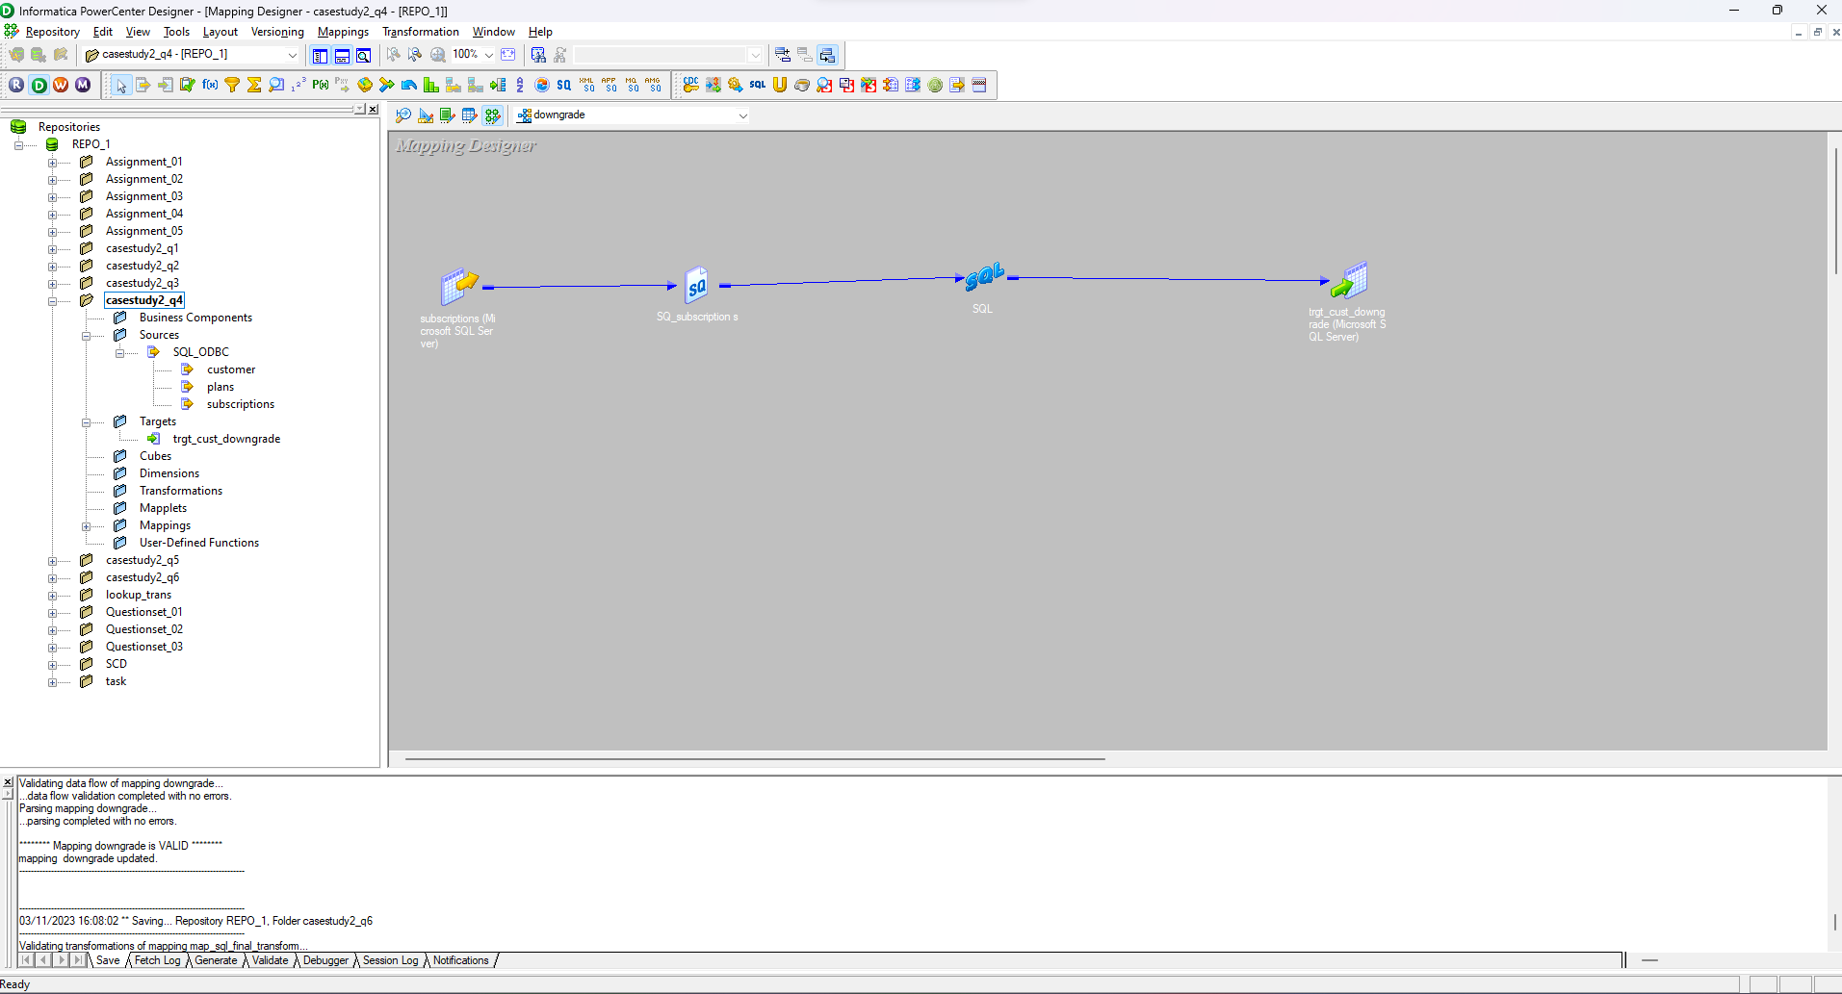

Workflow with run properties

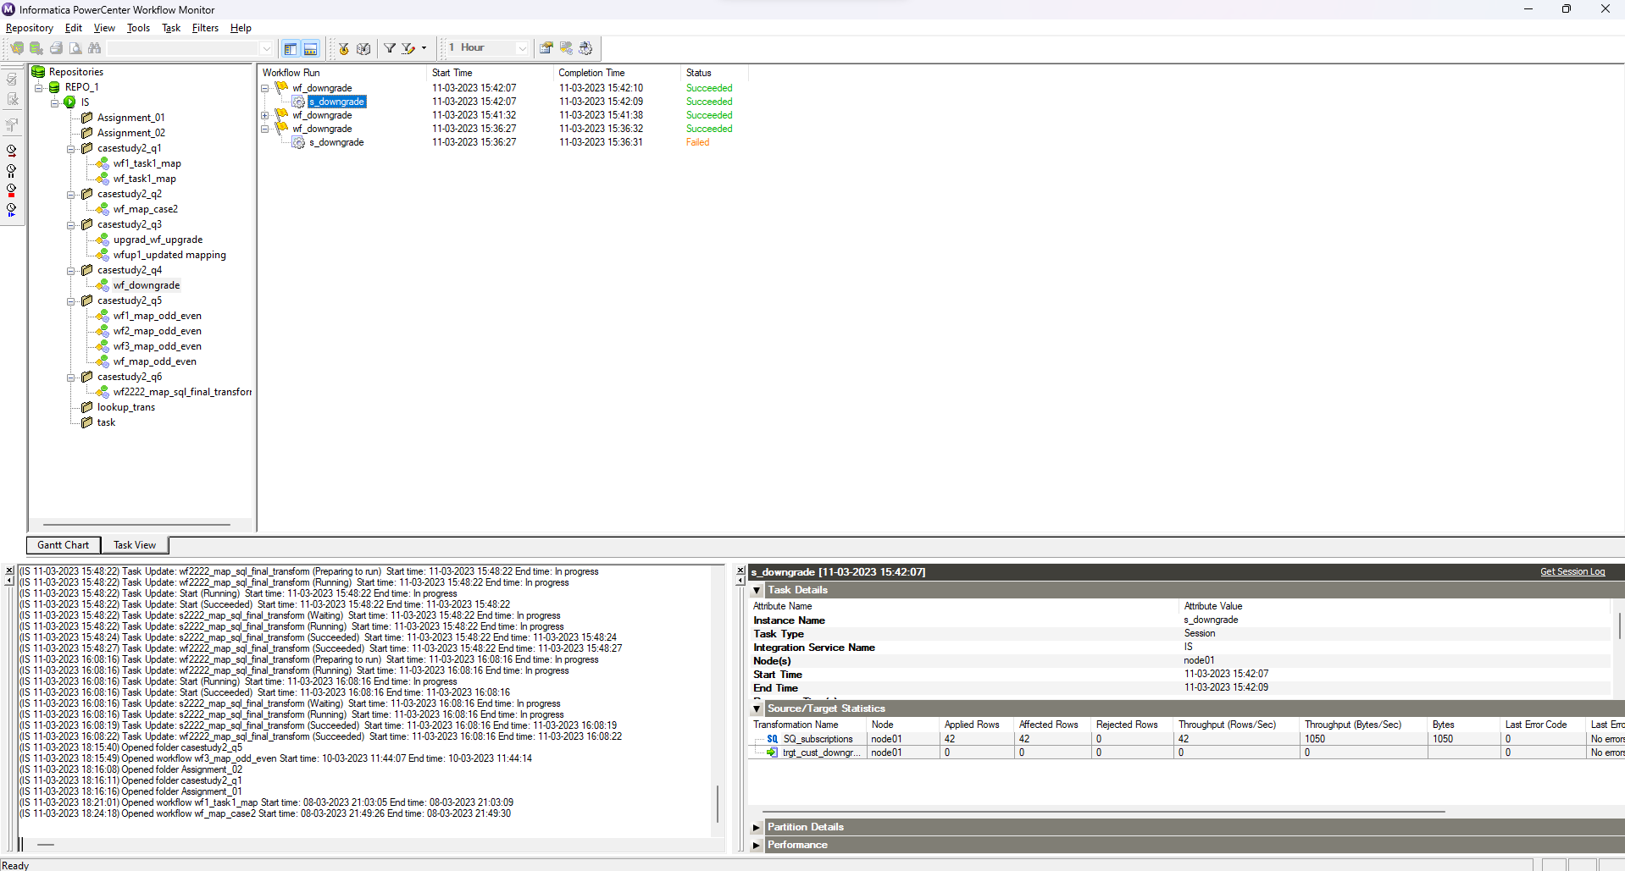

Database output:

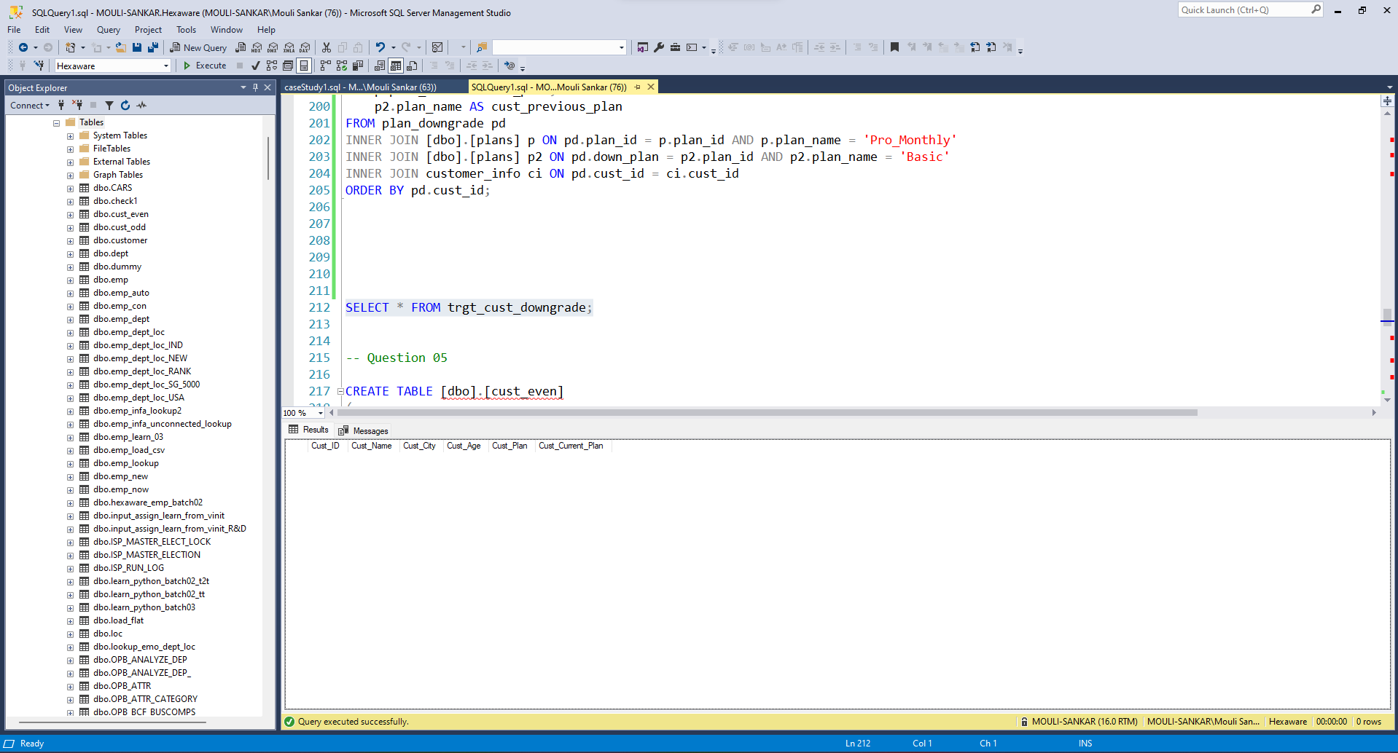**Note:** No person in the given data is downgraded**.**

**3.5 Question 5**

**Design Job in Informatica so that Customer with even age (like 18, 20, 22, 24 etc.) goes in even table and odd ages (like 17, 19, 21, 23 etc.) goes in odd table. Age will compute on the day of job run.**

Mappings:

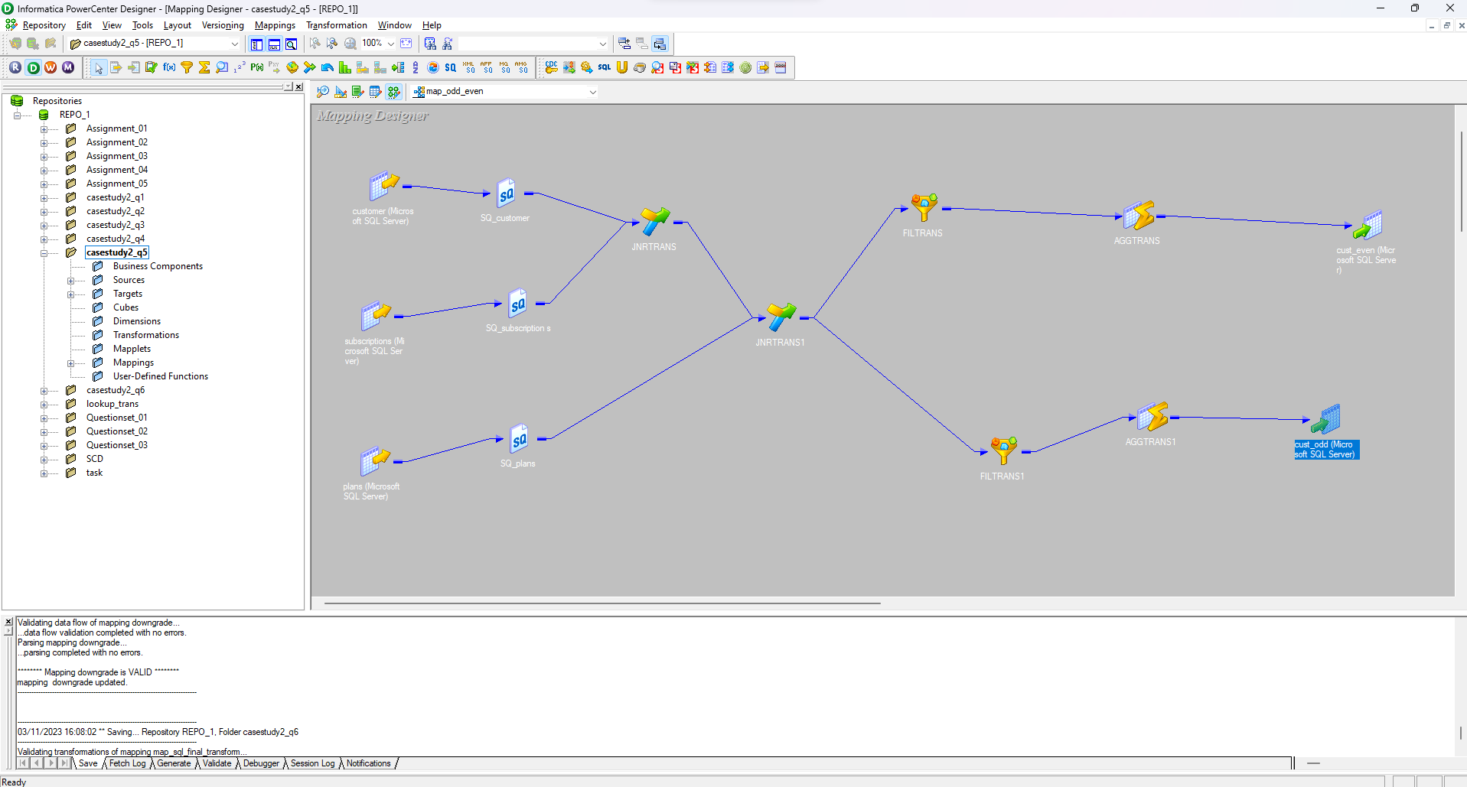

Workflow with run properties:

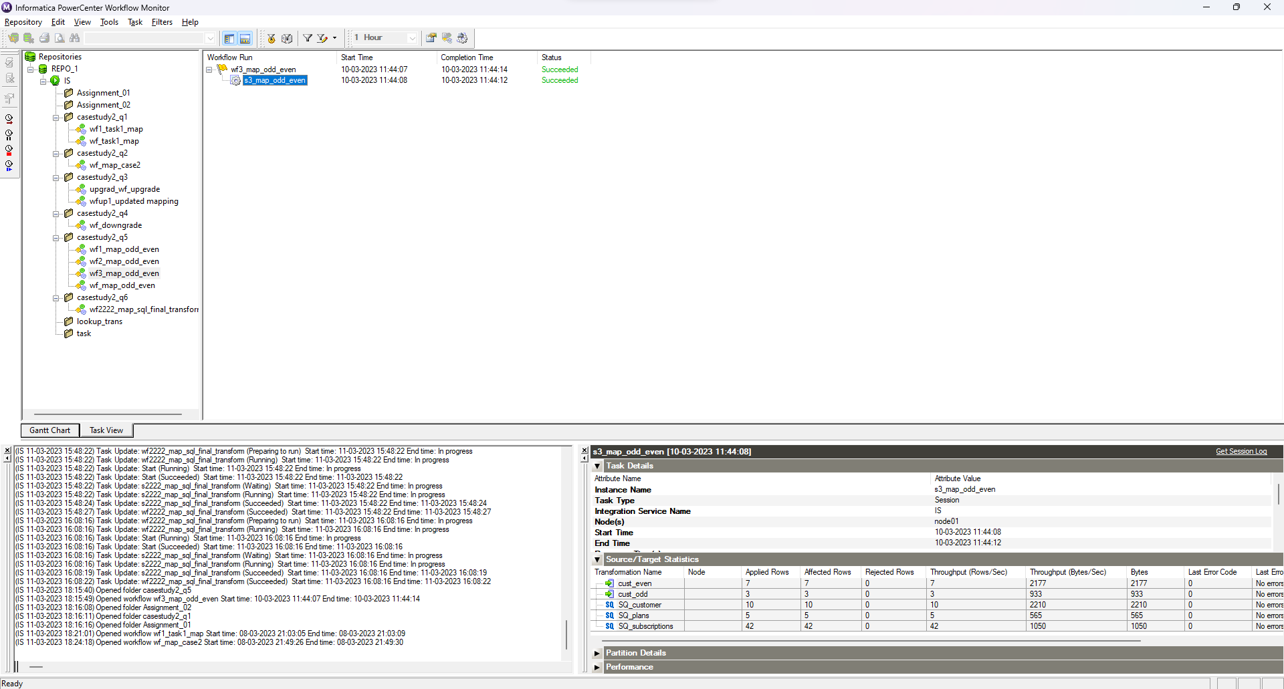

Database output:

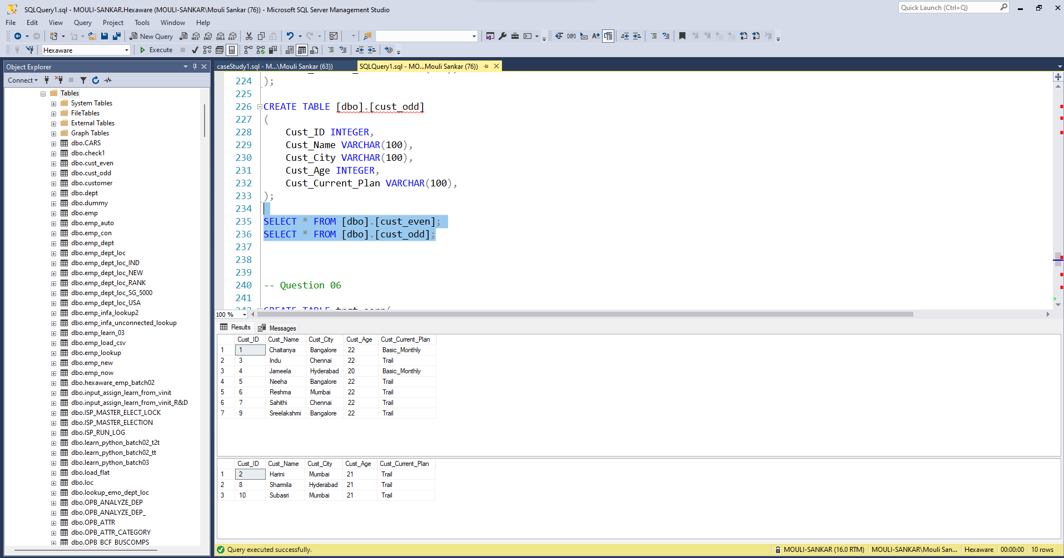**3.6 Question 6**

**Design a job in Informatica so that you get output, which summarize earning in year 2020, 2021, 2022 for each plan.**

Mappings:

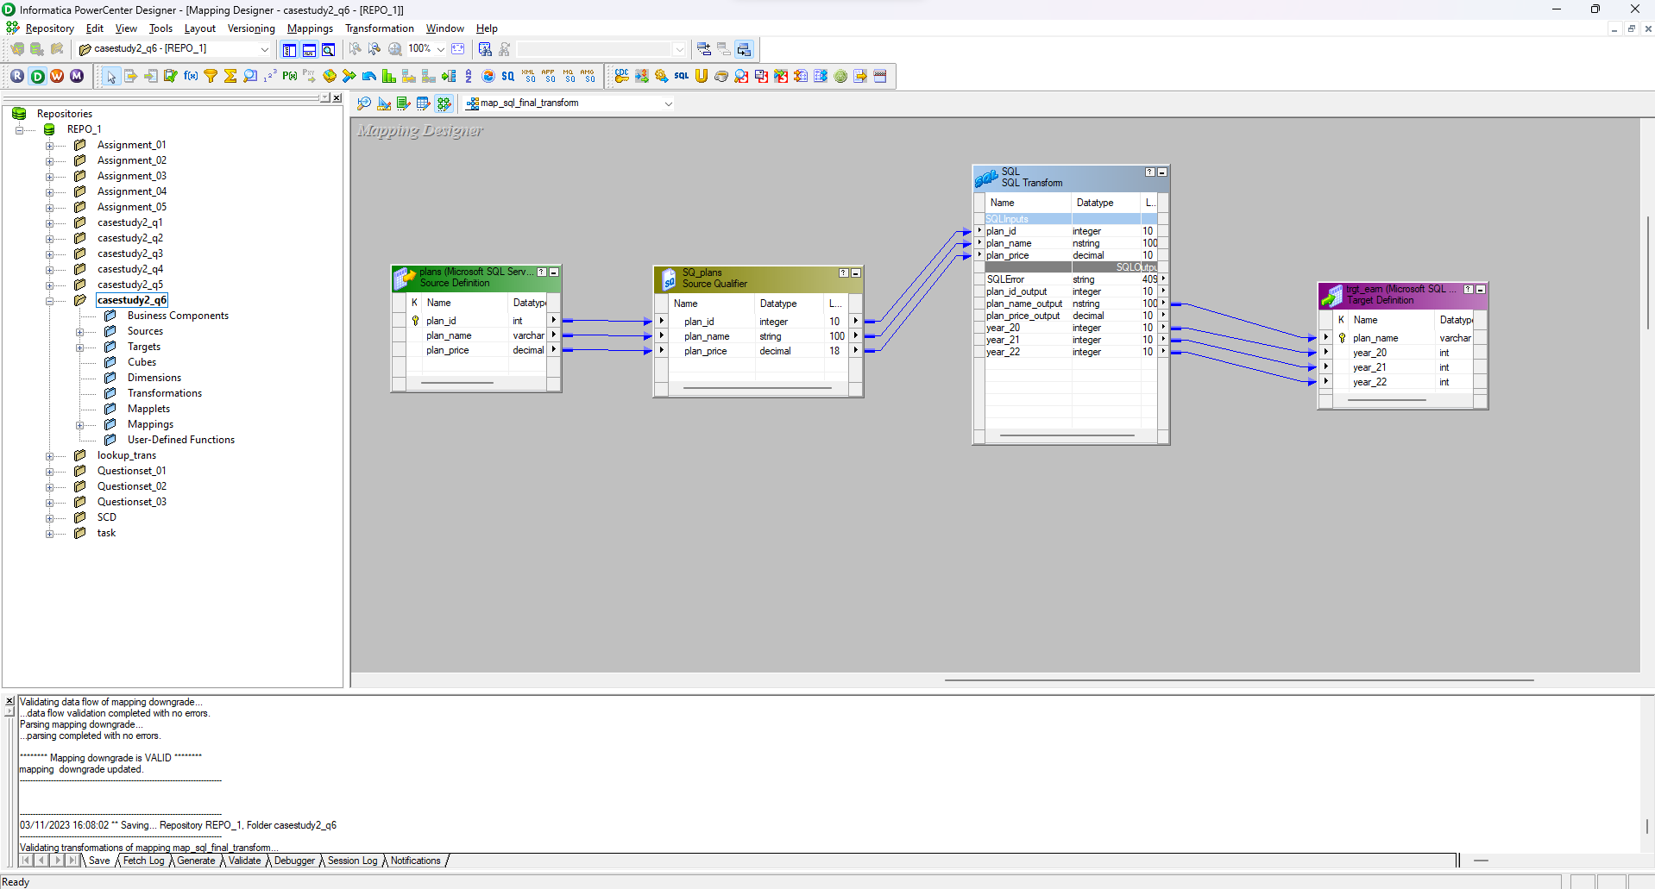

Workflow with run properties:

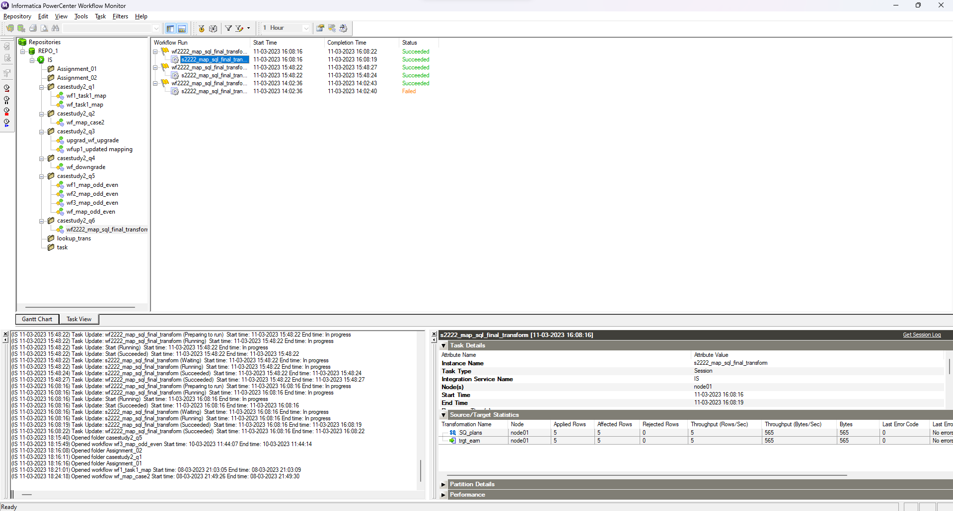

Database output:

